Siddhartha Shukla thrown out of the set of "Dil Se Dil Tak"

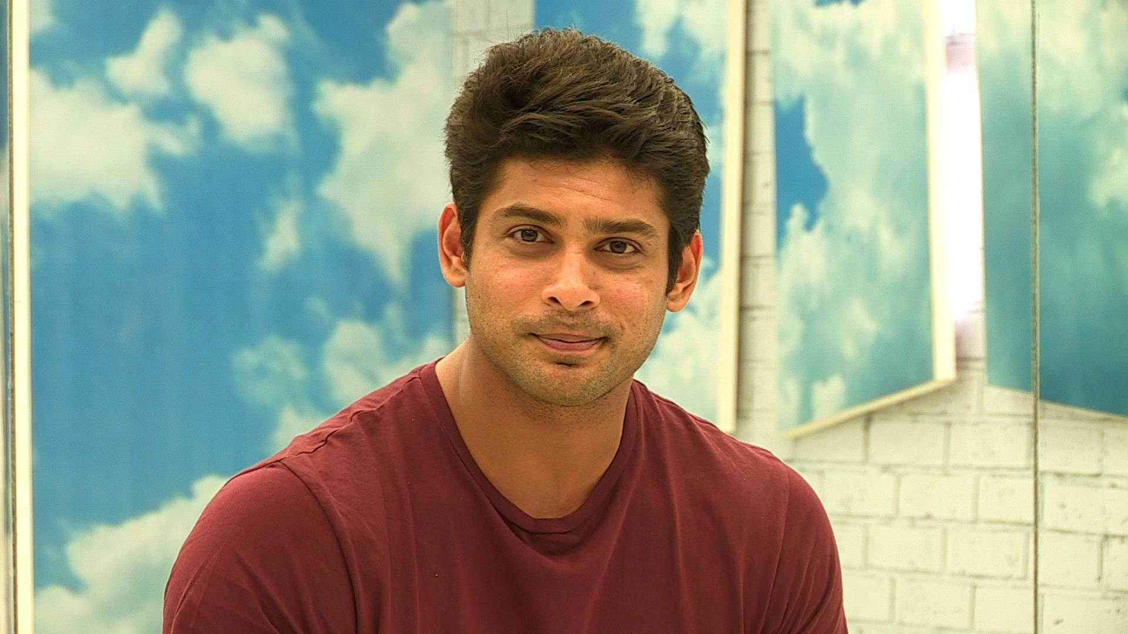Siddharth Shukla is again in the limelight of the buzz. The reason is not any new show, but his bad behaviour. It has been heard that Siddharth has been behaving badly on the set of "Dil Se Dil Tak" over the last several days.  
Sources say it is being told that this case was started a few days ago during a party. Actors Kunal Verma, Rashmi Desai and Jasmine Bhasin were also present in this party. According to the sources, during this party Siddhartha abused a lot under the influence of alcohol. When Kunal told him that he was not doing right, Siddhartha started shouting at him only. Actor Kunal complained to the production team about this scenario. When Project Head Sheetal wanted to talk to Siddharth, he did not spare her too. He even went on to say that he has offers from many shows and threatened to leave the show and even demand his payment so far. On this behaviour of Siddharth, the show head asked him to leave the show immediately and even to walk away from the set.  
As per the sources, Siddharth had behaved like this few days back and then he apologized and returned to the show. But looking at the latest situation, Siddharth seems to have stopped all the way back to the show.   
Let's see who will become the new "Parth"of "Dil Se Dil Tak".